**PLOT D**

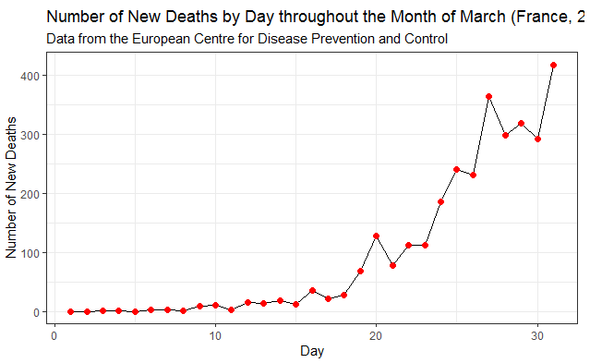

*title = (France, 2020)